Sunnam Navneet Kumar POC

Git Initial Configuration
- git config --global user.name "my username"
- git config --global user.email "navneet@example.com

19 Basic Git Katas:
- Basic Commits
I have used these commands
- git add – add files to staging
- git commit – like a savepoint with a message
- git status – tells the status of the branch, anything to commit
- git log – to view the commit history
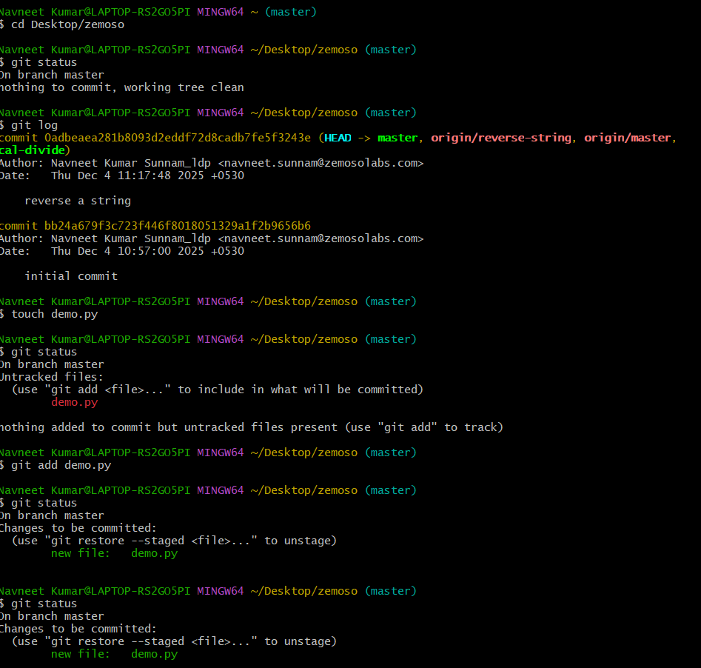

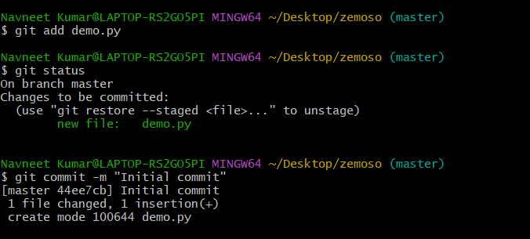
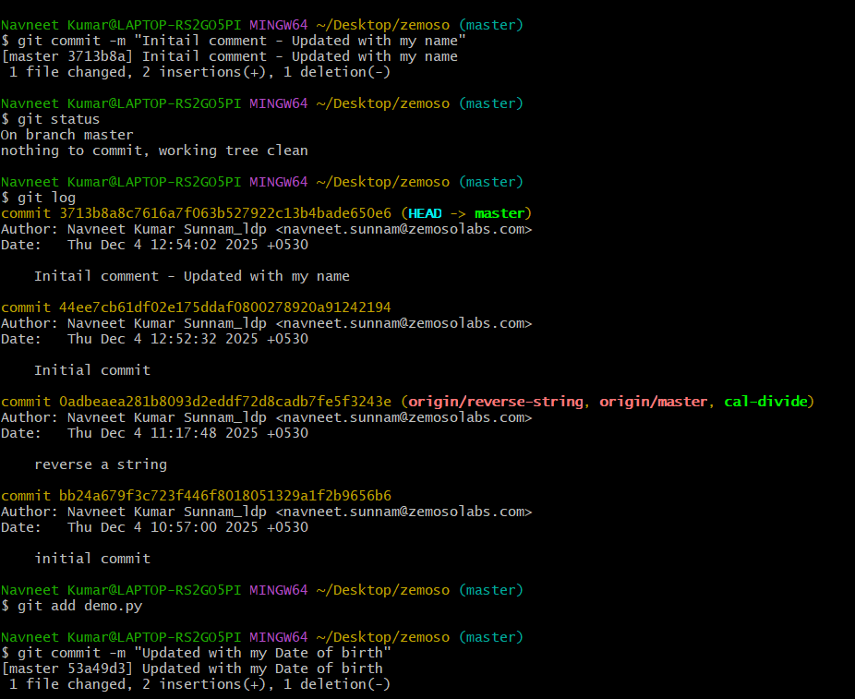

Git Kata: Basic Staging

I have used
- git add
- git commit
- git status
- git log
- git restore – to undo changes in working dir
- git diff – tells exactly what changed before you commit
- git diff –staged
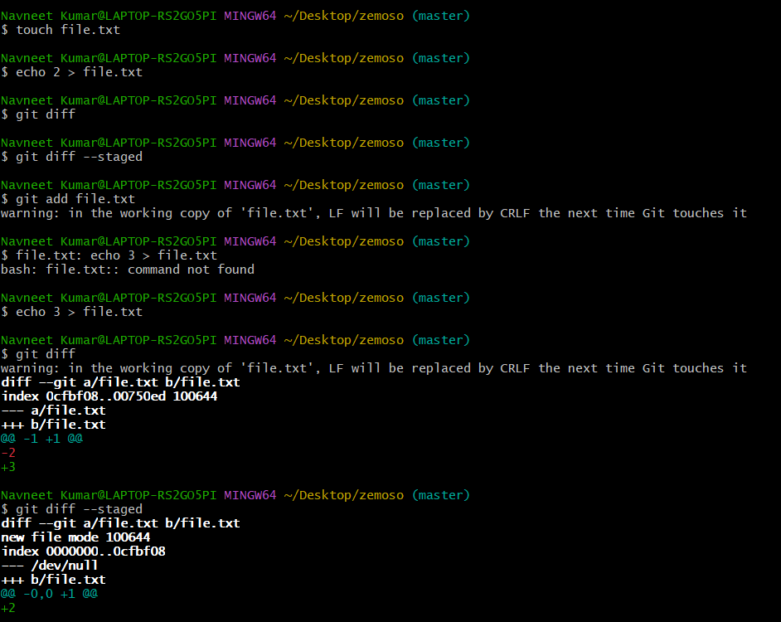
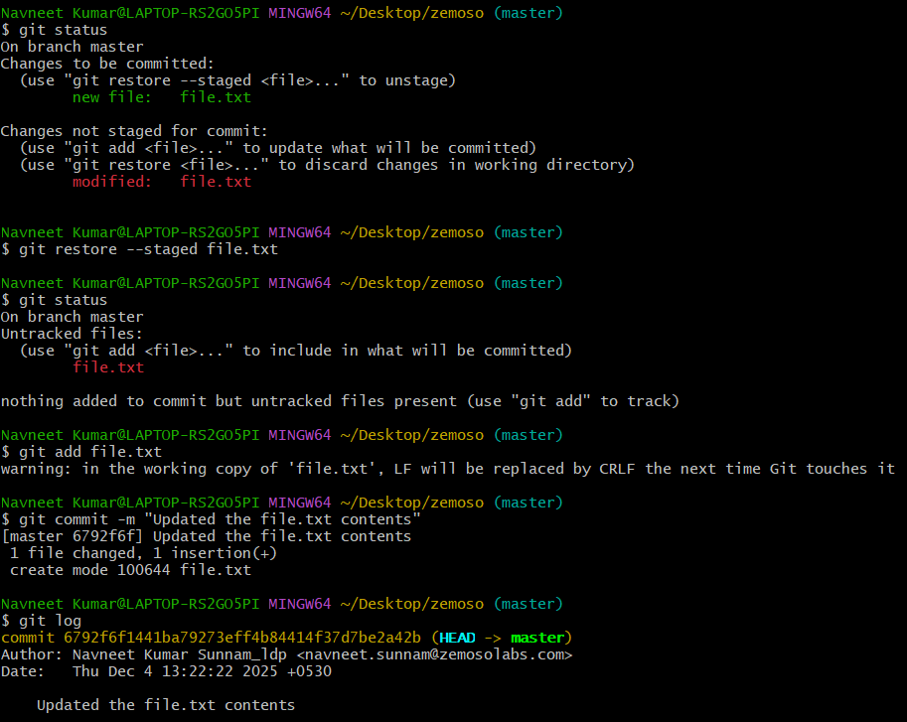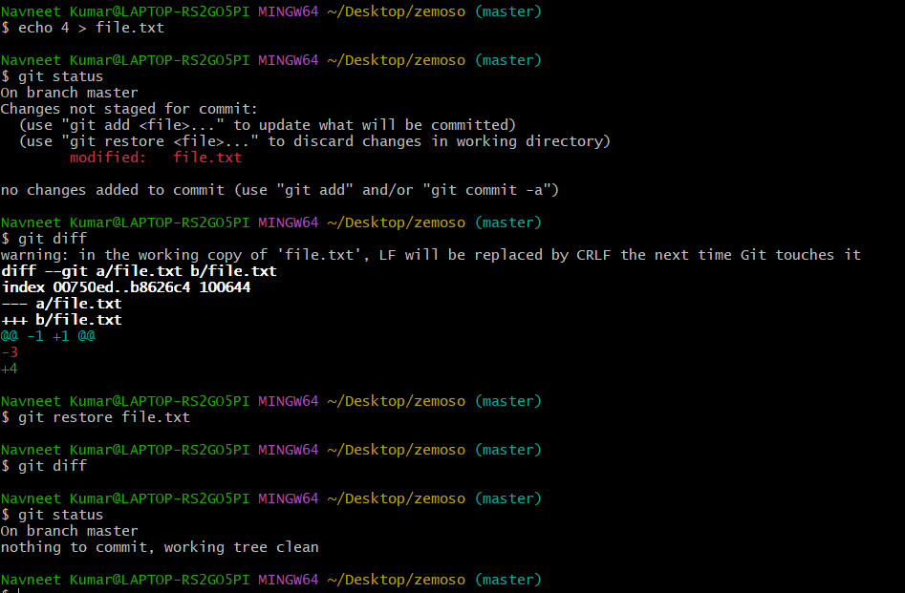

Git Kata: Basic Branching

I have used these commands
- git switch
- git log --oneline –graph – commit history
- git branch
- git diff – shows difference between working dir and staging area.

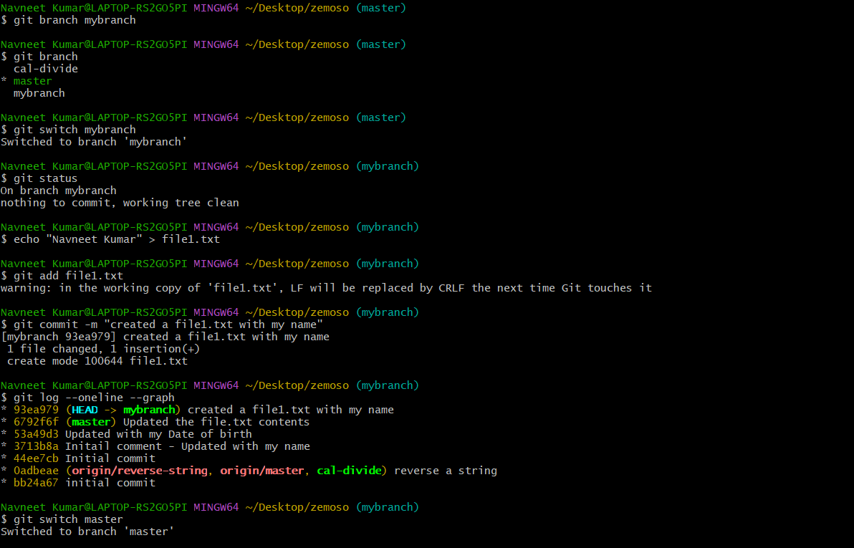
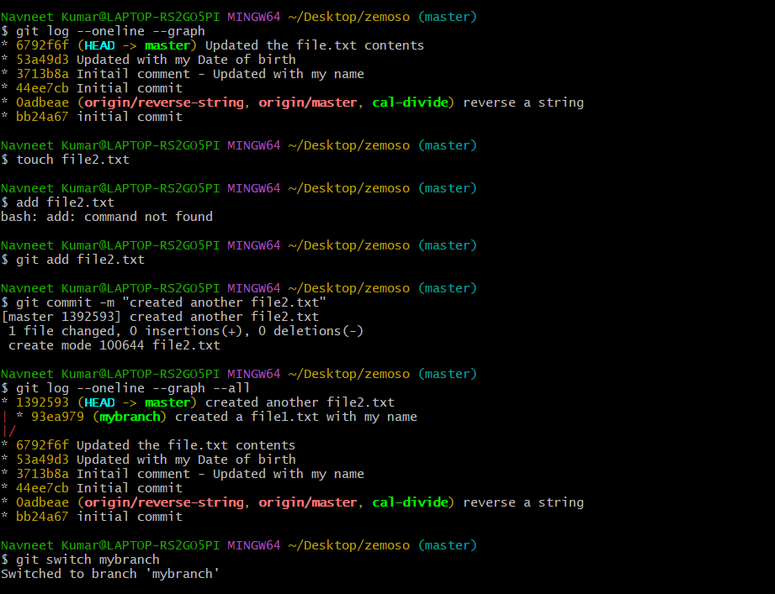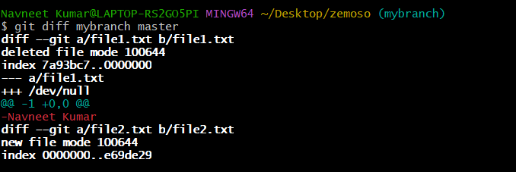

4.Git Kata: Fast-forward Merge
The branch you are merging has no new commits of its own
And the branch you're merging is ahead of the current branch.

I have used the following commands
- git branch -d <branch-name>
- git switch
- git merge <branch name>

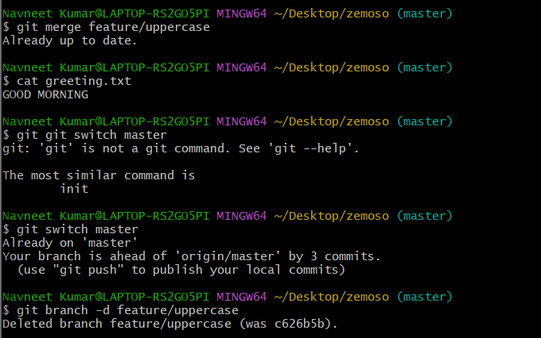

5.Git Kata: 3-Way Merge
The branch you are on has its own commits, and
The branch you want to merge also has its own commits.

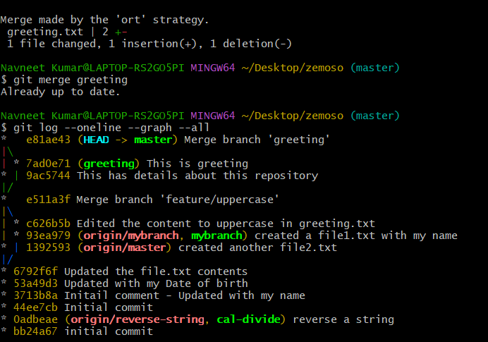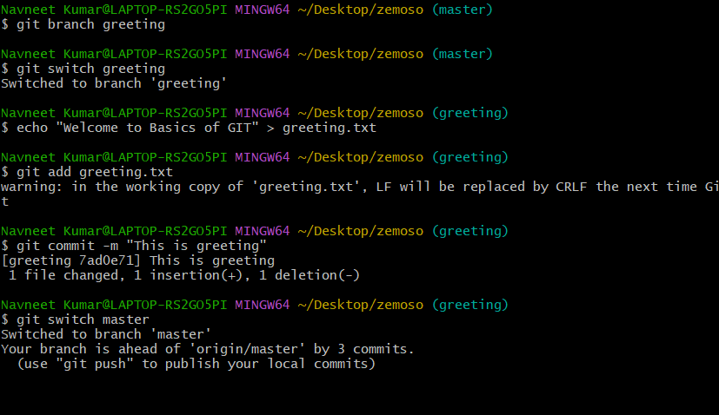

6. Git Kata: Merge Conflict

Git cannot automatically merge two branches forcing me to resolve error manually
This happens when two developers are working on same file and it doesn’t know which version to take.
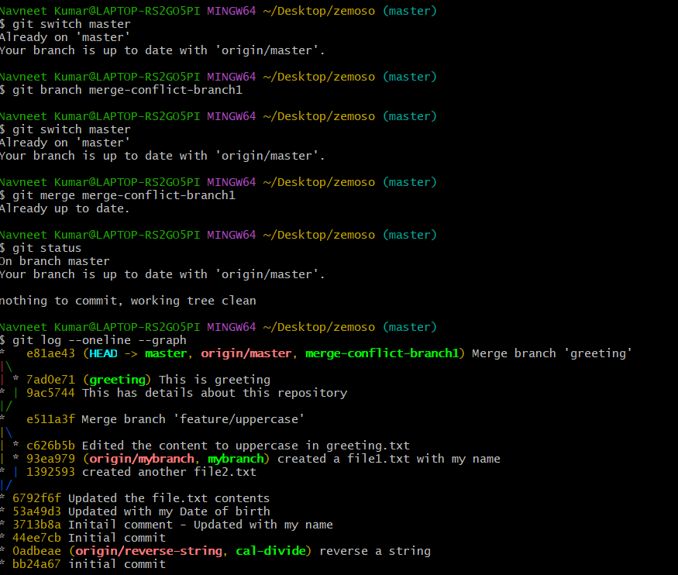

7.Git Kata: Merge Mergesort
Created a merge sort conflict and cleared it manually in notepad(conflict was abt the recursive and custom implementation)

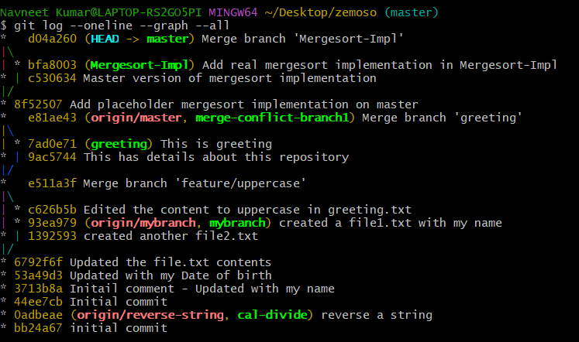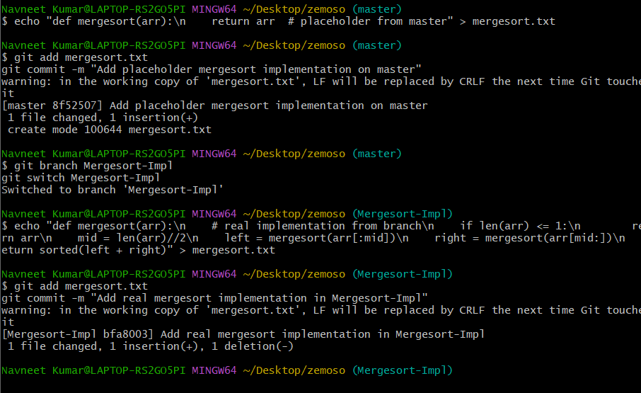

8. Git Kata: rebase branch
Rebase is just like replace all my commits on another branch
Git rebase <branch name>
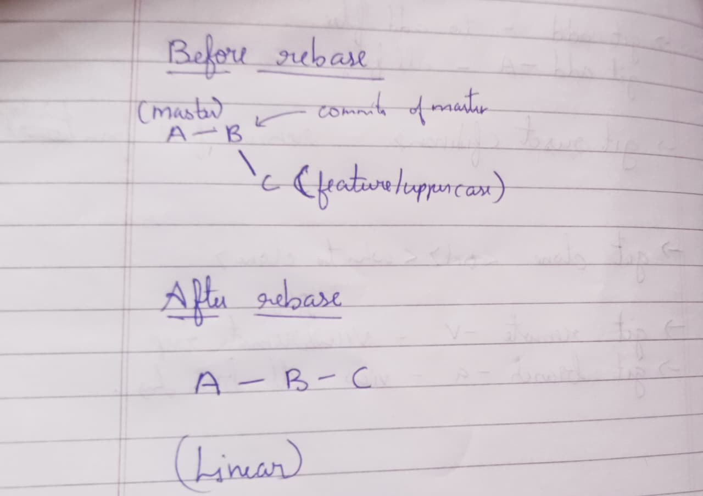

9. Git Kata: Basic revert
I have used the command revert.
Here I have basically have undone the changes in the greeting.txt.
Revert has created a new commit to undo the past commit. It will not delete history instead adds a commit to reverse changes.

10. Git katas: Git reset
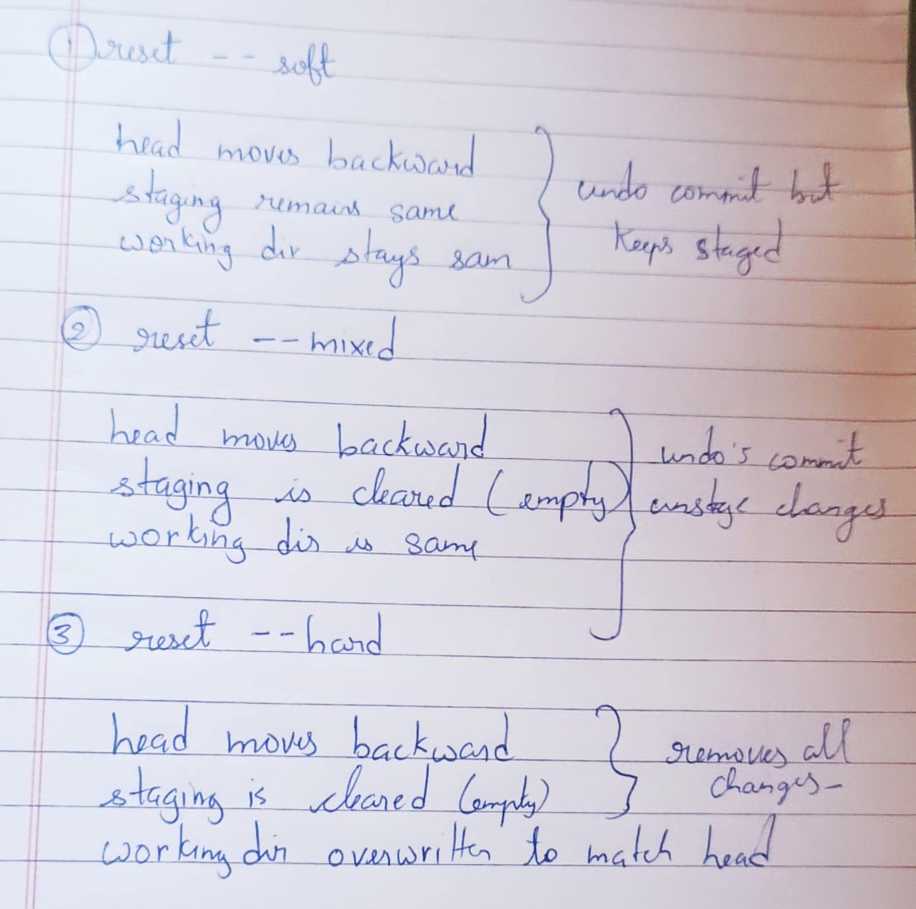

11. Git Kata: Basic cleaning
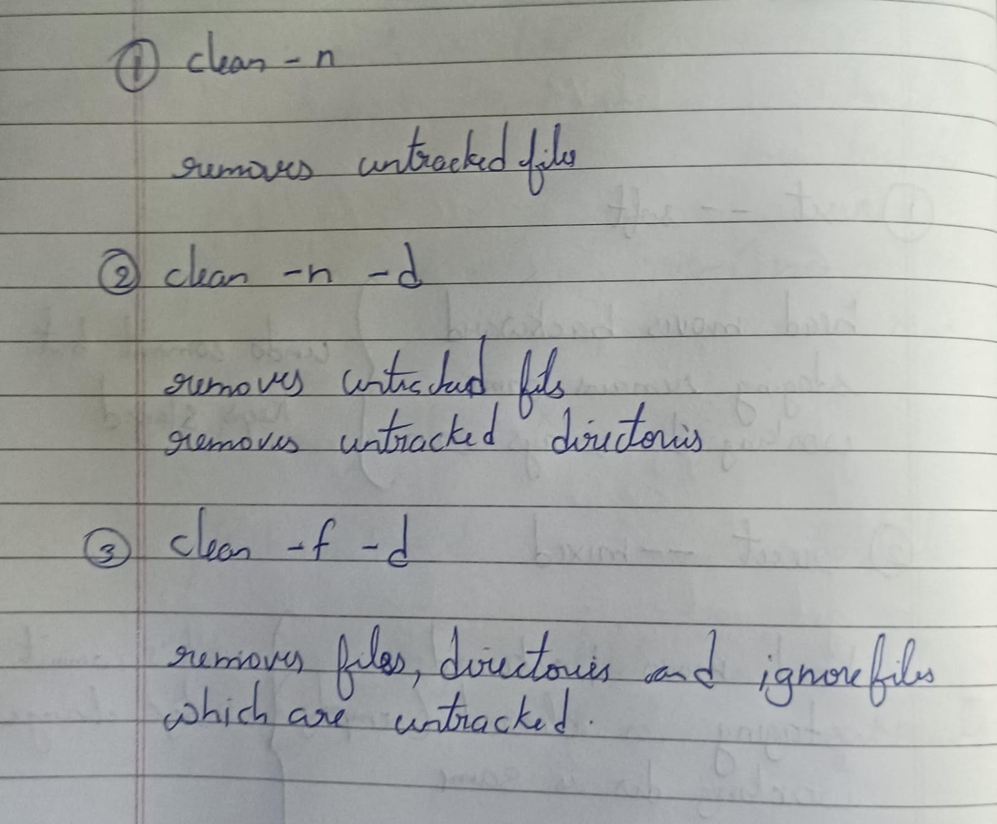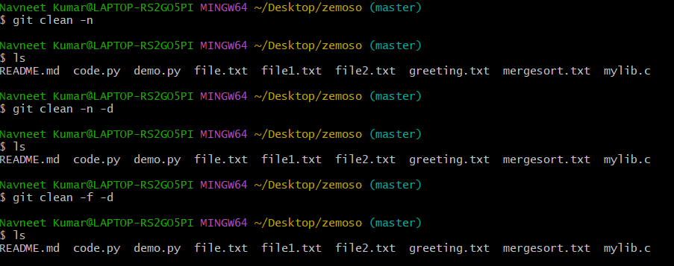

12. Git kata: Amending commits
Git commit –amend – this replaces the recent commit with a new one
If you the same command again without editing the content it will just replace the sha indicating that the previous commit has been replaced with new one,

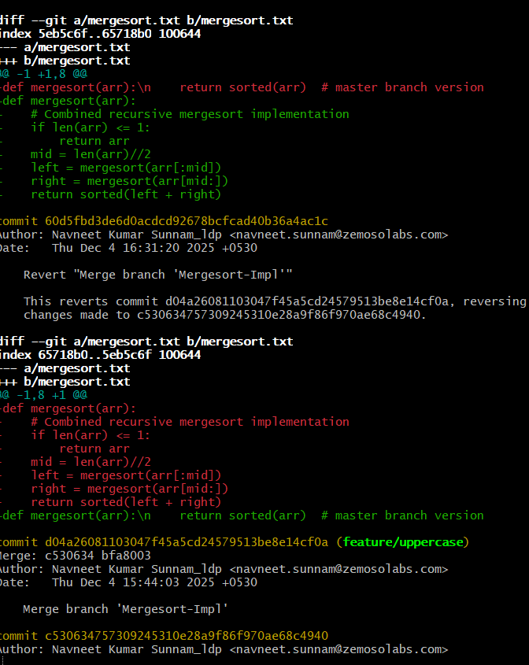

13. Git kata: reflog commits
This is like a time machine with shows everything that has been deleted.
With reflog you can see the deleted commits so that you can restore it using its sha code with the reset command.
Example:
echo "A" > file.txt
git add file.txt
git commit -m "A"

echo "B" >> file.txt
git add file.txt
git commit -m "B"

echo "C" >> file.txt
git add file.txt
git commit -m "C"

Log status
A — B — C (HEAD)

Deleted C accidentally
git reset --hard HEAD~1

Log looks like
A-B(head)

git reflog
This shows my deleted commit with SHA code. Copy the code and use it with reset command to restore the commit.
git reset –hard <SHA code>

it gets restored.
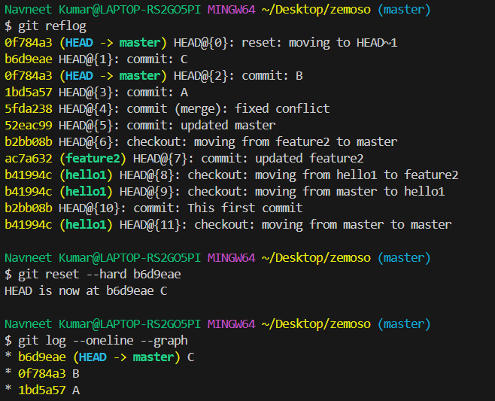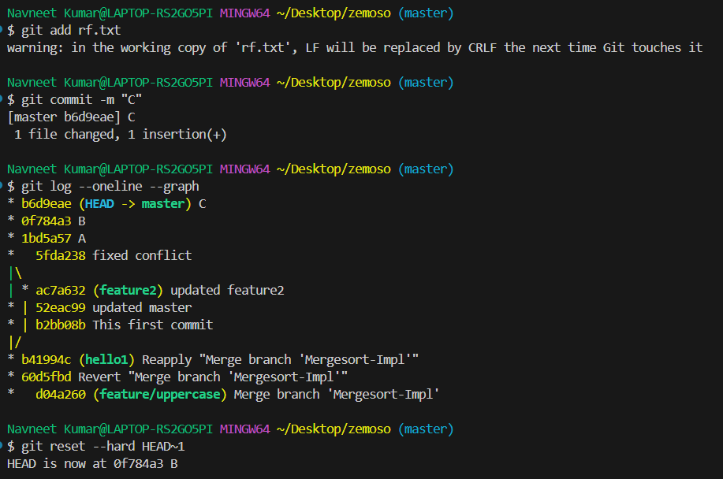
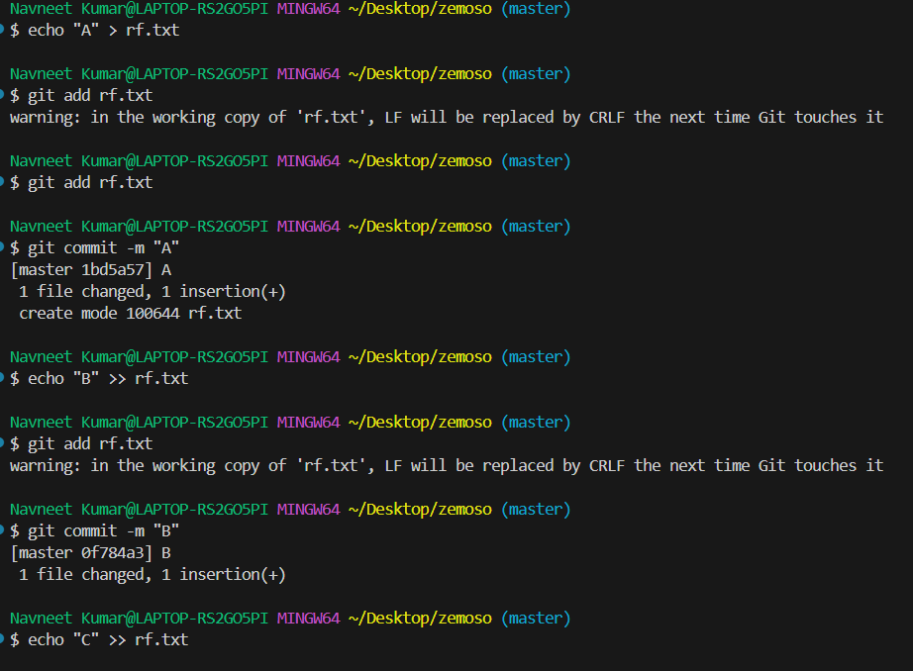

We can also delete history from reflog but this is not recommended,
git reflog expire --expire=now --all

14. Git kata : Squash commits
Squashing is basically cleaning the unnecessary commits and combining them into one for a clear structure of the Log.
So here is an example:
I have 3 commits in log.
A
B
C
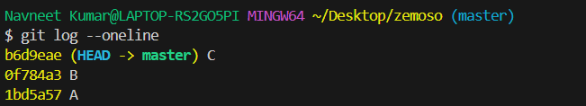
I want to rebase them as One commit and present in my log.
git rebase -i HEAD~3
edit will open and you need to pick one and squash the rest.
Pick A
Squash B
Squash C
Save and close. Another editor will open where you can commit your message as one.
And then close it. You are done
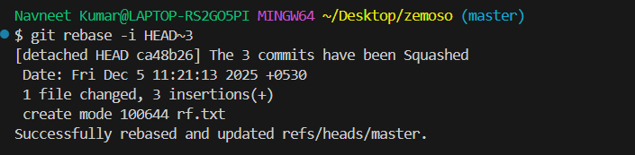
Now you can see the log, squashing has been done. Cleaned the unwanted commits into a single commit message.

15. Git kata : Advanced interactive rebase
If your log history is completely messy and you want to restructure it and present it you can do it with rebase interactive.
For this you use the following methods
Pick – base commit
Squash – merge commits into one
Reword- keeps the commit same but edits the message
Drop – removes from history
Fixup – applies changes to previous commit and removes its message.

My log looked like this:
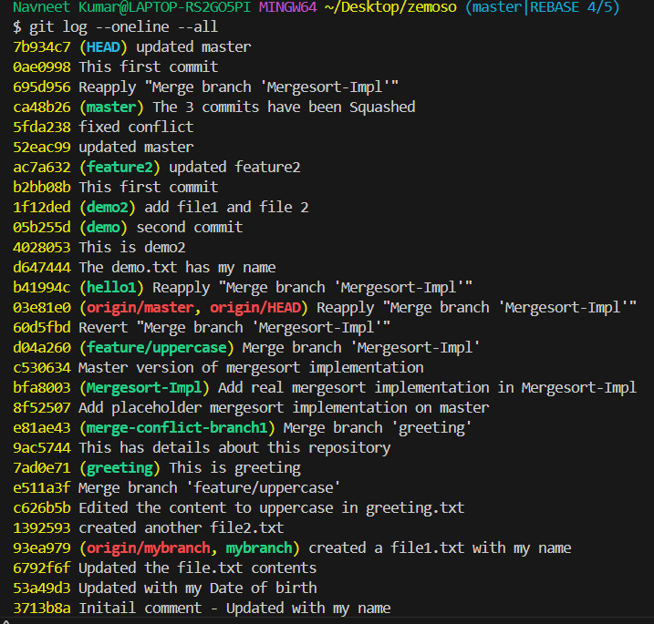
I have used the rebase to fix all that:
git rebase -i –root (edits all the commits)
git rebase -I HEAD~3(edits commits as the number mentioned)

this will open an editor where you edit the commits using following commands
pick
squash
drop
fixup
reword
Now my Log looks like this:
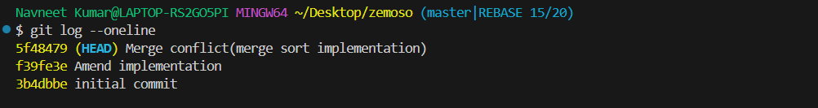

16. Git Kata: Basic stashing
Stashing is basically storing the staged and unstaged files temporarily which you don’t want to commit.
You want to do this because you want to work on someother file which you want to fix and commit.
To show implementation,
I have created two files
Stage.txt (to show staged and unstaged)
Bug.txt(the one which I want to work and commit the changes using staging)

I have set an unstaged file and a staged file just like this:
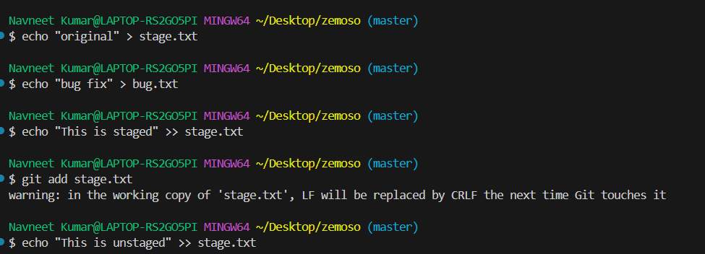
Now I used stash to store it temporarily and worked on bug.txt and committed it.
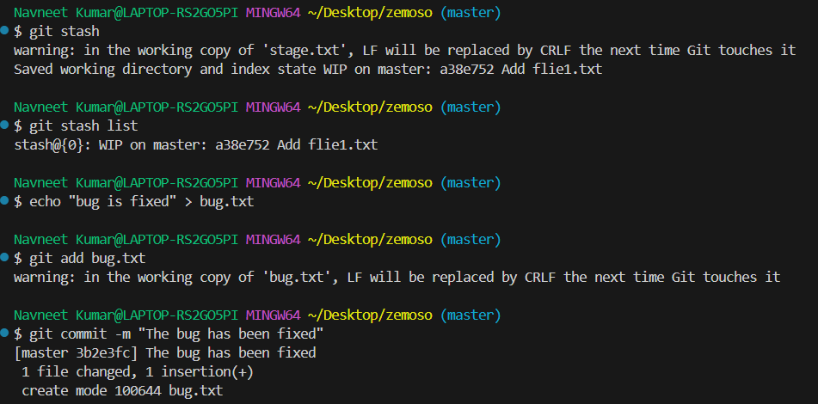
After fixing and committing bug.txt I have restored it used stash apply
git stash apply (restored the unstaged file)
git stash apply –index (restores both staged and unstaged)
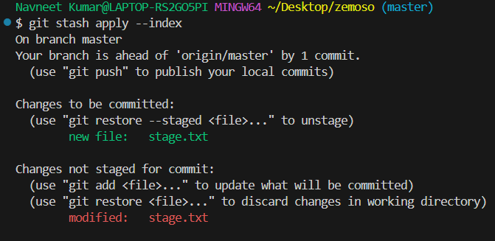

Used drop to drop the list
git stash drop
git stash list (lists the stash files)
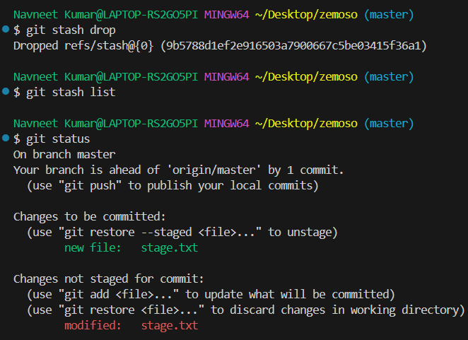

17. Git Kata: Basic Ignore

This .gitignore helps you to ignore newly created untracked files with a particular extension.
To create one, for example I want to ignore files with .s extension.
echo “*.s” > .gitignore
git add .gitignore
git commit -m “Ignore .s extension files”
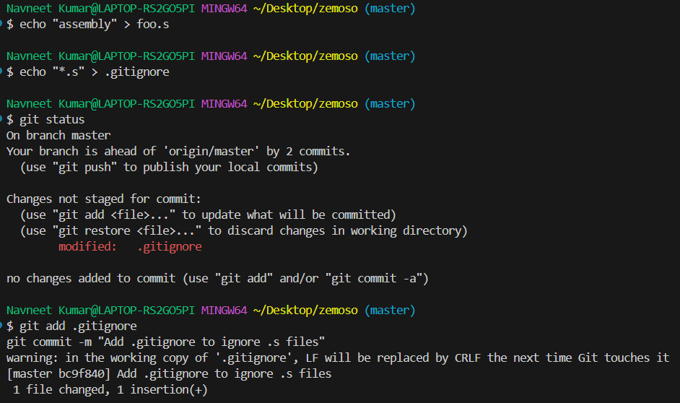

This ignores all the newly created files and the untracked files.
It doesn’t change the previously created tracked files.
To remove the file and untrack it we use,
git rm --cached
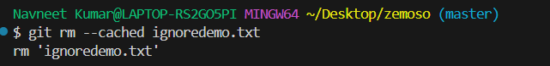
For special files not be ignore we need to edit the ignore file like this,
echo “!special.txt” >> .gitignore
19. Git Kata: Tagging of the commits
Tags are the ones that give labels to the commits and don’t change or move.
They are of 2 types
- lightweight tags
git tag v1.0 A

- Annotated tags
git tag -a v0.1 -m “This is initial commit”
This gives the tag message, creator name and date.
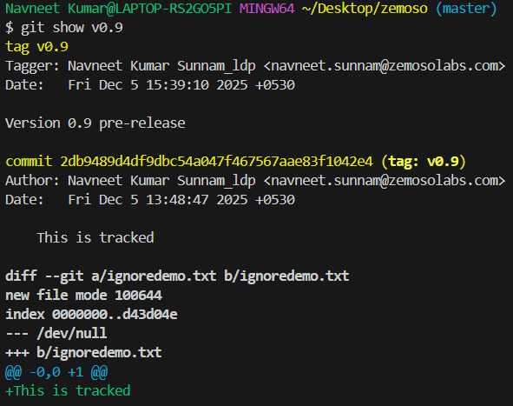

To delete a tag
git tag -d <tag>
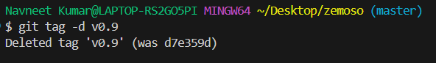
To list tags
git tag –list “*v”

Git katas: Commit on wrong branch
When ever you commit on a wrong branch by mistake, you can reverse that very easily.
First switch to which you have done a mistake, them reset it using
git reset –hard HEAD~1
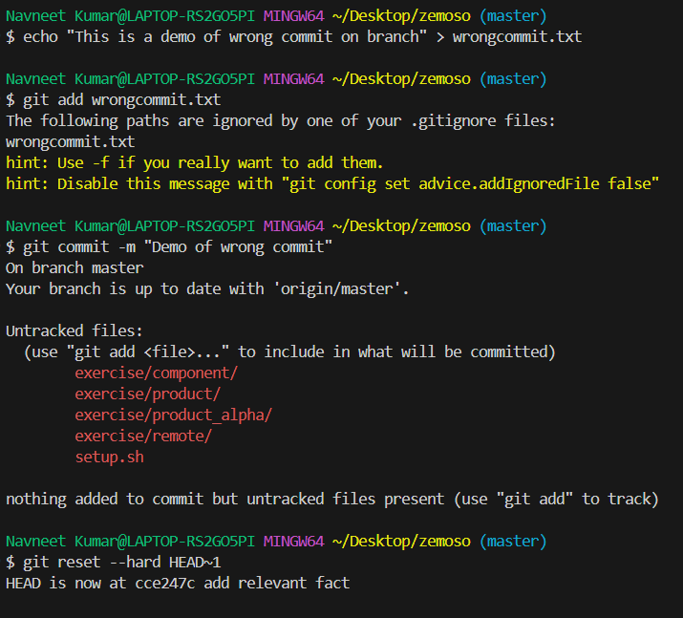
Then switch to the correct branch and then add and commit the file.
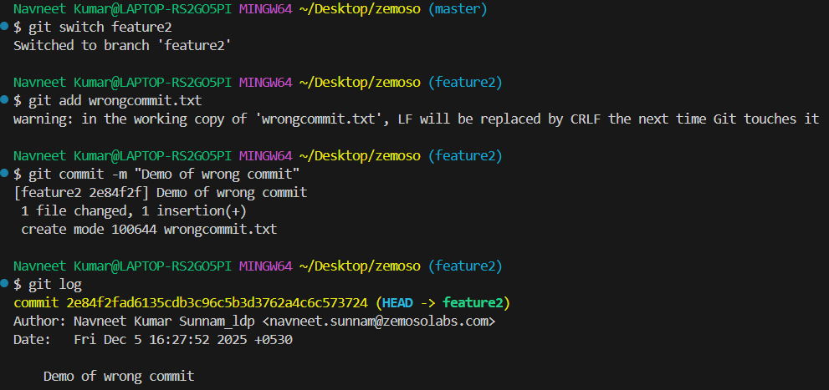
git cherry-pick <sha>
This will directly pick the commit and place it on top of any other commit in any branch. This is helpful when perform commits on wrong branches
Git Kata: Save my commit
I have done the following task.

Use git log to see that the history is brief
Use ls to verify that holygrail.txt is not in the workspace
Use git reflog to find the commit that added holygrail.txt
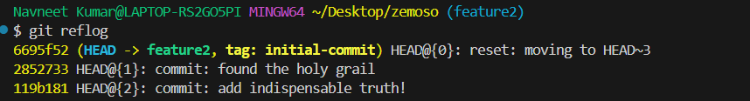
Use git reset --hard to recover our history and work
Use git log and ls to see the recovered work
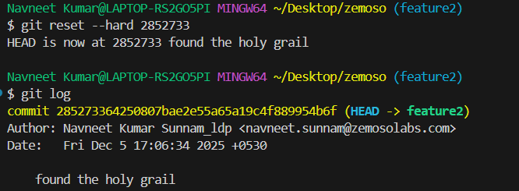
Undo your solution by running git reset --hard initial-commit
Use git cherry-pick to restore holygrail.txt
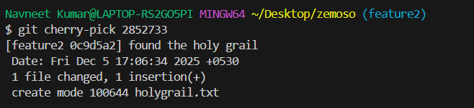
Force the Git garbage collector to run with git gc. It cleans up unnecessary git data.
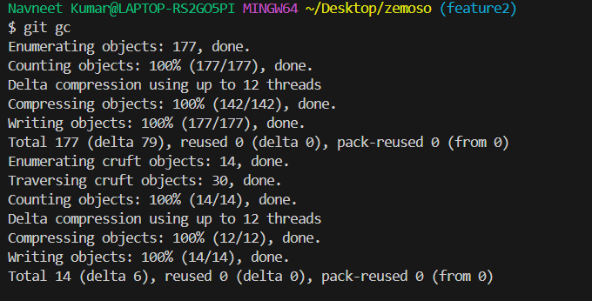

Git Kata: Git attributes file
This file tells you how specific files should behave.
Similar to gitignore but this doesn’t remove, it basically specifies the behaviour of the files.
Example:
If I specify this in my git attributes file,
*.txt text eol=lf
*.bat text eol=crlf

Then all the .txt files will follow LF eol (/n) and all .bat files will follow CR + LF eol (/r /n).

Git kata : Bad Commit
Bisect helps you to fix bugs that come through bad commits. It is a powerful debugging tool. It uses binary search that means it goes to the middle commit and let you see for the bug and based on your answer it narrows down the searche. This makes it fast and accurate.

First start the bisect using
Git bisect start
Make the current commit as bad
Git bisect bad
Then let it know which is the known good commit.
Git bisect good <SHA>
Now it searches for the commit where the bug was actually introduced based on your answers and then you tell which is good and bad.
Then you can reset the bisect and revert(remove) it completely to fix.
Git reset bisect

Git Kata: Git objects
git ls-tree <branch or commit> lists the contents like files and folders stored inside a commit, branch without checking it out.
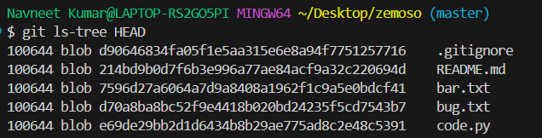
git cat-file -p <SHA> used to inspect git objects directly likes commits, files, trees etc.
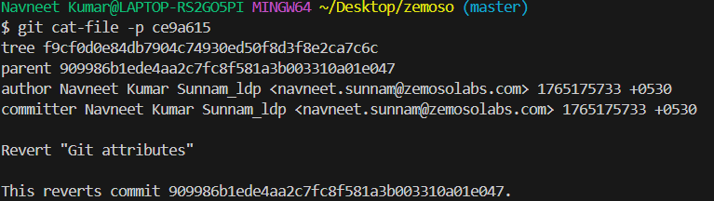
PULL REQUEST
Pull request is a way to request your changes to be reviewed and after approval to be merged into another branch.
WHY PR?
Pull Requests help with:
- Code review
- Team collaboration
- Preventing direct pushes to main
- Catching bugs early
How I rasied a pull request?
First I created a new branch feature-login with login.html file.
I have added and made changes to the login.html and now I want to raise a PR.
I have pushed the branch to remote after changes.
Now I have clicked on compare and pull request on GitHub.
Set the base and compare branch and gave the title and description.
And created a pull request.
Now waiting for the reviewers to review and request for changes. Once approved merged the feature-login branch to master branch.
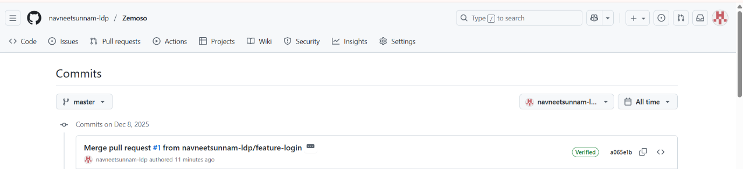
Common Queries?
Pull vs fetch
Fetch – downloads the updates only.
Pull – Downloads and merges them immediately. (fetch + merge).
How to undo a wrong pull?
git reset --hard HEAD~1

